**DAILY ONLINE ACTIVITIES SUMMARY**

|  |  |  |  |
| --- | --- | --- | --- |
| **Date:** | 31/05/2020 | **Name:** | Krishnitha |
| **Sem & Sec** | 4th sem, A Section | **USN:** | 4AL18CS039 |
| **Online Test Summary** | | | |
| **Subject** | NA | | |
| **Max. Marks** | NA | **Score** | NA |
| **Certification Course Summary** | | | |
| **Course** | Trailhead Basics | | |
| **Certificate Provider** | Sales force | **Duration:** | 3hrs |
| **Coding Challenges** | | | |
| **Problem Statement:**  Write a Java program to calculate nPr. | | | |
| **Status:** Executed | | | |
| **Uploaded the report in GitHub** | | YES | |
| **If yes Repository name** | | <https://github.com/krishnitha/Java-coding> | |
| **Uploaded the report in slack** | | YES | |

Certification Course Details:

Today I have done certification course on TRAILHEADBASICS. I learnt about the Picklist Administration. I also learnt how to create custom objects in My Trailhead Playground. I completed this particular module as well as Data Modelling concepts.

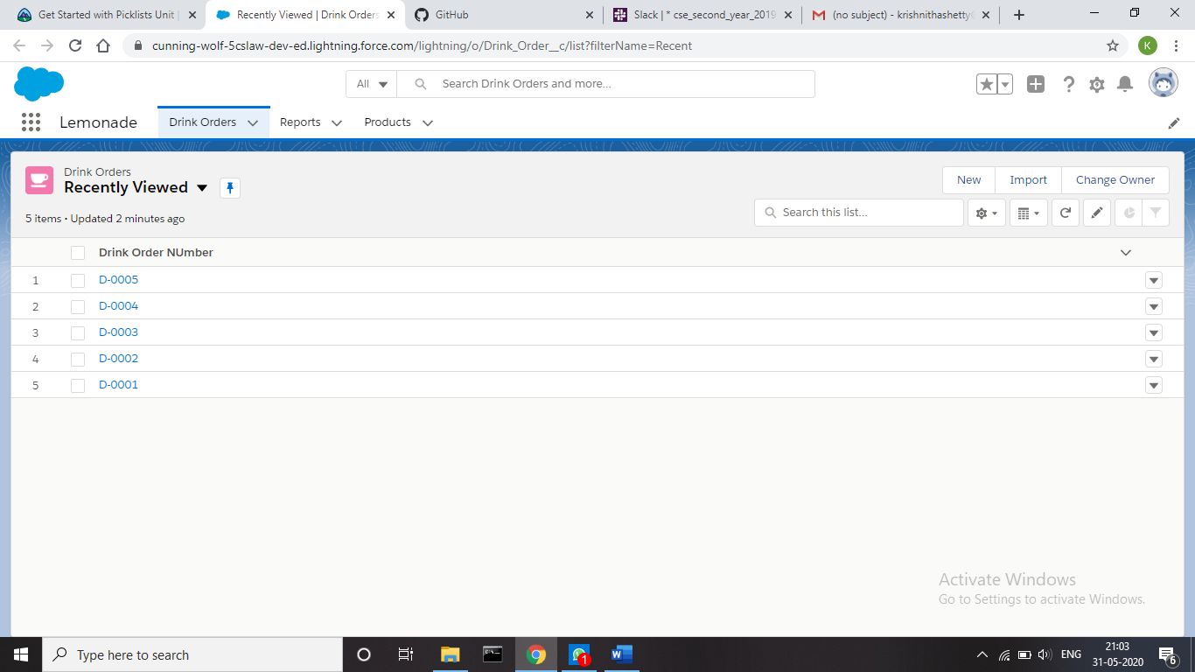



Coding Challenges Details:

Problem 1: Write a Java program to calculate nPr.

nPr represents n permutation r and value of nPr is (n!) / (n-r)!

**Input:** The first line of the input contains T denoting the number of testcases. T testcases follow. First line of the test case will be the value of n and r respectively.

**Output:** For each test case, in a new line, output will be the value of nPr.

**Constraints:**

1 <= T <= 100

1 <= n, r <= 20

n <= r

**Example:**

Input:

2

2 1

10 4

Output:

2

5040

**Solution:** Uploaded it in GitHub

